**Secondary Sales System Automation Project**

Software Requirements Specification

Revision History

|  |  |  |  |
| --- | --- | --- | --- |
| **Date** | **Version** | **Description** | **Author** |
| 02/08//18 | 1.0 | Draft |  |
|  |  |  |  |

Table of Contents

1. Introduction
   1. Purpose
   2. Scope
   3. Definitions, Acronyms, and Abbreviations
   4. Overview
2. Overall Description
3. Structural Model
4. Modules and Functionality
   1. Central Module
      1. BusinessHierarchy Management
      2. Customer/ DB Management
      3. Outlet Management
      4. Calendar Management
      5. Sales Force Management
      6. Inventory Management
      7. Product & Price Management
      8. Rebate/Claim Management
      9. Sales Promotion Management/ Trade promotion
      10. Target Management
      11. Bulk Data Upload.
      12. Focus SKU/Brand
      13. Message
      14. Reports
   2. Mobile Application Module
      1. Route wise Sales Order
      2. New Outlet creation
      3. Outlet GPS Verification
      4. Trade Promotion
      5. Sync
      6. Product List
      7. Message
      8. Reports
      9. Update
      10. Delivery Module
      11. Target view
      12. Spot Sales
   3. DB House Operation Module
      1. Purchase Management
      2. Outlet Management
      3. Inventory Management (challan & Product)
      4. Day End Restriction
      5. Mobile Sales/ DBH Order Management
      6. Reports
5. Specific Requirements
   1. Usability
      1. Graphical User Interface
      2. Accessibility
   2. Reliability & Availability
      1. Back-end Internal Computers
      2. Internet Service Provider or Intranet
   3. Performance
   4. Security
      1. Data Transfer
      2. Data Storage
   5. Supportability
      1. Configuration Management Tool
   6. Design Constraints
      1. Standard Development Tools
      2. Web Based Product
   7. On-line User Documentation and Help System Requirements
   8. Purchased Components
   9. Interfaces
      1. User Interfaces
      2. Hardware Interfaces
      3. Software Interfaces
      4. Communications Interfaces
   10. Licensing Requirements
   11. Legal, Copyright, and Other Notices
   12. Applicable Standards
   13. Supporting Information

# Introduction

The introduction of the Software Requirements Specification (SRS) provides an overview of the entire SRS with purpose, scope, definitions, acronyms, abbreviations, references and overview of the SRS. The aim of this document is to gather and analyze and give an in-depth insight of the complete **Transcom Beverage Limited Secondary Sales Automation software system (SSS)** by defining the problem statement in detail. Nevertheless, it also concentrates on the capabilities required by stakeholders and their needs while defining high-level product features. The detailed requirements of the **Transcom Beverage Limited** are provided in this document.

## Purpose

The purpose of the document is to collect and analyze all assorted ideas that have come up to define the system, its requirements with respect to consumers. Also, we shall predict and sort out how we hope this product will be used in order to gain a better understanding of the project, outline concepts that may be developed later, and document ideas that are being considered, but may be discarded as the product develops.

In short, the purpose of this SRS document is to provide a detailed overview of our software product, its parameters and goals. This document describes the project's target audience and its user interface, hardware and software requirements. It defines how our client, team and audience see the product and its functionality. Nonetheless, it helps any designer and developer to assist in software delivery lifecycle (SDLC) processes.

## Scope

Primarily, the scope pertains to the SSS (Secondary Sales System) features for making Transcom Beverage Limited project live. It focuses on the company, the stakeholders and applications, which allow for online Order, Delivery and Analysis of TBL products.

This SRS is also aimed at specifying requirements of software to be developed but it can also be applied to assist in the selection of In-house and commercial software products. The standard can be used to create software requirements specifications directly or can be used as a model for defining a organization or project specific standard. It does not identify any specific method, nomenclature or tool for preparing an SRS.

## Definitions, Acronyms, and Abbreviations

|  |  |
| --- | --- |
| Configuration | It means a product which is available / Selected from a catalogue can be customized. |
| FAQ | Frequently Asked Questions |
| CRM | Customer Relationship Management |
| RAID 5 | Redundant Array of Inexpensive Disk/Drives |
| PSS | Primary Sales System |
| TBL | Transcom Beverage Limited |
| NFR | Non- Functional Requirement |
| SSS | Secondary Sales System |

## Overview

The remaining sections of this document provide a general description, including characteristics of the users of this project, the product's hardware, and the functional and data requirements of the product.  General description of the project is discussed in section 2 of this document.  Section 3 gives the Modules and functional requirements, data requirements and constraints and assumptions made while designing the SSS.  It also gives the user viewpoint of product.  Section 3 also gives the specific Modules and functional requirements of the product.

# Overall Description

This document contains the problem statement that the current system is facing which is hampering the growth opportunities of the company. It further contains a list of the stakeholders and users of the proposed solution. It also illustrates the needs and wants of the stakeholders that were identified in the brainstorming exercise as part of the requirements workshop. It further lists and briefly describes the major features and a brief description of each of the proposed system.

The following SRS contains the detail product perspective from different stakeholders. It provides the detail product functions of SSS with user characteristics permitted constraints, assumptions and dependencies and requirements subsets.

# Structural Model

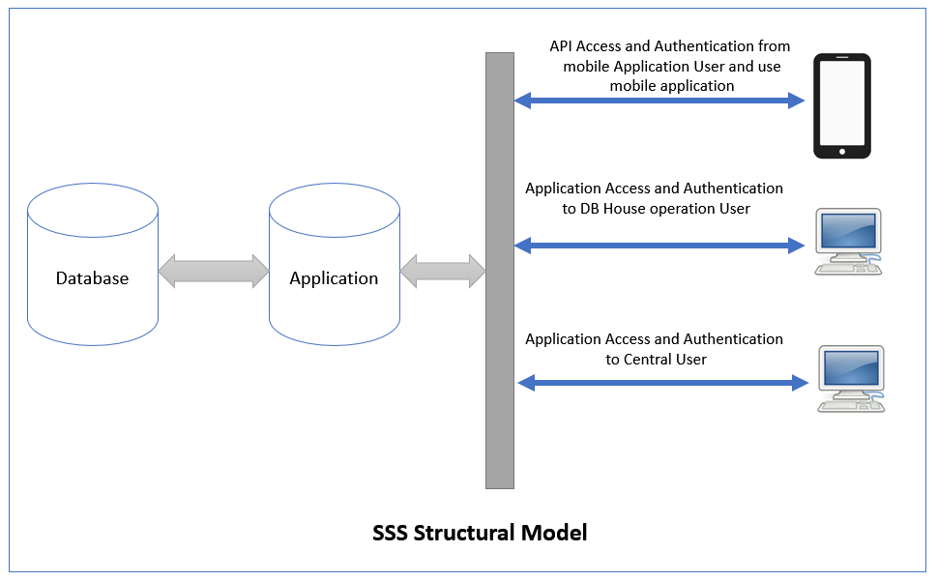

­­­­

# Modules and Functionality

## Central Module

#### The Module shall use for System Configuration

### **Business Hierarchy Management**

#### The Sub Module shall use for Hierarchy configuration.

#### The Sub Module shall use for Add/ Modify Business Hierarchy Element

#### The Sub Module shall use for change Business Hierarchy Element Level.

### **Customer/ DB Management**

#### The Sub Module shall use for Customer/Distribution House Configuration.

#### The Sub Module shall use for Cluster Configuration.

#### The Sub Module shall use for Distribution House Employee (PSR/Operator/Delivery Man) Configuration and management.

#### The Sub Module shall use for Distribution House Employee Access and Authentication

### **Outlet Management**

#### The Sub Module shall use for Distribution House Outlet Configuration.

#### The Sub Module shall use for Distribution House Route/Sub Route Configuration.

#### The Sub Module shall use for PSR Route Plan Manage & Configuration.

#### The Sub Module shall use for outlet channel Configuration.

#### The Sub Module shall use for outlet Grade Configuration.

#### The Sub Module shall use for outlet type Configuration.

### **Calendar Management**

#### The Sub Module shall use for Holyday management.

### **Sales Force Management**

#### The Sub Module shall use for Managing Sales Force Access

#### The Sub Module shall use for Manage top level user Access and Authentication

### **Inventory Management**

#### The Sub Module shall use for DB House Inventory Control and Inventory Adjustment.

#### The Sub Module shall use for Primary and Secondary Inventory synchronization.

### **Product & Price Management**

#### The Sub Module shall use for Product configuration and manage.

#### The Sub Module shall use for Product pricing as a bundle for DB Houses.

#### The Sub Module shall use for Product pricing as a bundle with Price batch.

### **Rebate/Claim Management**

#### The Sub Module shall use for mange claim as per trade promotion.

### **Sales Promotion Management/ Trade promotion**

#### The Sub Module shall use for manage trade promotion.

### **Target Management**

#### The Sub Module shall use for manage DB House/PSR wise Target.

#### The Sub Module shall use for update DB House/PSR wise Target.

### **Balk Data Upload.**

#### The Sub Module shall use for upload balk outlet data.

#### The Sub Module shall use for upload balk Target Data.

#### The Sub Module shall use for upload balk Route/sub route Data.

### **Focus SKU/Brand**

#### The Sub Module shall use for focus some product on PSR mobile Application.

### **Message**

#### The Sub Module shall use for sending message to Mobile application.

### **Reports**

#### The Sub Module shall use for generate various type of sales and Analytical reports

## Mobile Application Module

### **Route wise Sales Order**

#### The Sub Module shall use for show route/sub route outlet as per route plan.

#### The Sub Module shall use for create order to an outlet.

#### The Sub Module shall use for getting picture on VisiCooler Outlet.

#### The Sub Module shall use for Showing Trade promotion on Product List.

#### The Sub Module shall use for getting Current GPS Location.

#### The Sub Module shall use for getting timestamp of order.

### **New Outlet creation**

#### The Sub Module shall use for create new outlet on current sub route.

### **Outlet GPS Verification**

#### The Sub Module shall use for outlet GPS Location.

#### The Sub Module shall use for getting outlet image.

### **Trade Promotion**

#### The Sub Module shall use for showing current Trade Promotion List.

### **Sync**

#### The Sub Module shall use for Automatic data sync Mobile application to web API.

#### The Sub Module shall use for manual data sync Mobile application to web API.

### **Product List**

#### The Sub Module shall use for showing product List with current price.

### **Message**

#### The Sub Module shall use for showing message sanded from Central module.

### **Reports**

#### The Sub Module shall use for current order detail.

#### The Sub Module shall use for PSR performance.

### **Update**

#### The Sub Module shall use for update mobile application.

### **Delivery Module**

#### The Sub Module shall use for delivery previous orders.

#### The Sub Module shall use for change/update order.

### **Target view**

#### The Sub Module shall use for view user target.

### **Spot Sales**

#### The Sub Module shall use for order with delivery on sub route.

## DB House Operation Module

### **Purchase Management**

#### The Sub Module shall use for entry primary challan

#### The Sub Module shall use for receive primary challan which receive from Primary data.

### **Outlet Management**

#### The Sub Module shall use for update outlet information.

### **Inventory Management (challan & Product)**

#### The Sub Module shall use for create challan against order.

#### The Sub Module shall use for Inventory deduction on delivery.

### **Day End Restriction**

#### The Sub Module shall use for restriction on previous delivery.

### **Mobile Sales/ DBH Order Management**

#### The Sub Module shall use for update Order,

#### The Sub Module shall use for create new & update Order.

#### The Sub Module shall use for display detailed invoice for current order once it is confirmed

#### The Sub Module shall use for print Invoice on pre-fixed size.

### **Reports**

#### The Sub Module shall use for generate various type of sales and Analytical reports

# Specific Requirements

## Usability

### **Graphical User Interface**

#### The system shall provide a uniform look and feel between web application.

#### The system shall provide an online digital application system for user.

#### The system shall provide use of icons and toolbars.

### **Accessibility**

#### The system shall provide handicap access.

#### The system shall not provide multi language support.

## Reliability & Availability

### **Back-end Internal Computers**

The system shall provide storage of all databases on redundant computers with automatic switchover.

The system shall provide for replication of databases to off-site storage locations.

The system shall provide RAID V Disk Stripping on all database storage disks.

### **Internet Service Provider**

The system shall provide a contractual agreement with an internet service provider for T3 access with 99.9999% availability.

The system shall provide a contractual agreement with an internet service provider who can provide 99.999% availability through their network facilities onto the internet.

## Performance

The product shall be based on web base application and has to be run from a central server.

The product shall take initial load time depending on internet/intranet connection strength which also depends on the media from which the product is run.

The performance shall depend upon hardware components of the users.

## Security

### **Data Transfer**

The system shall use secure sockets in all transactions that include any confidential information.

The system shall automatically log out all customers after a period of inactivity.

The system shall confirm all transactions with the user’s web browser.

The system shall not leave any cookies on the user’s computer containing the user’s information.

The system shall not leave any cookies on the user’s computer containing any of the user’s confidential information.

### **Data Storage**

The user’s web browser shall never display a user’s password. It shall always be echoed with special characters representing typed characters.

The system’s back-end servers shall never display a user’s password. The user’s password may be reset but never shown.

The system’s back-end servers shall only be accessible to authenticated administrators.

The system’s back-end databases shall be encrypted.

## Supportability

### **Configuration Management Tool**

The source code developed for this system shall be maintained in configuration management tool.

## Design Constraints

### **Standard Development Tools**

The system shall be built using a standard browser base development tool that conforms to either IBM’s CUA standards or Microsoft’s GUI standards or other Tools.

### **Web Based Product**

        There are no memory requirements

        The computers must be equipped with web browsers such as Internet chrome/explorer/Mozilla/Opera.

        The product must be stored in such a way that allows the client easy access to it.

        Response time for loading the product should take no longer than five minutes.

        A general knowledge of basic computer skills is required to use the system

## On-line User Documentation and Help System Requirements

As the product is SSS, On-line help system becomes a critical component of the system which shall provide –

It shall provide specific guidelines to a user for using the SSS system and within the system.

To implement online user help, link and search fields shall be provided.

## Purchased Components

Not Applicable

## Interfaces

There are many types of interfaces as such supported by the SSS software system namely; User Interface, Software Interface and Hardware Interface.

There shall be logical address of the system in IPv4 format.

### **User Interfaces**

The user interface for the software shall be compatible to any browser such as Internet Explorer, Chrome, Mozilla or Netscape Navigator by which user can access to the system.

The web user interface shall be implemented using any tool or software package ASP.net MVC, ASP.Net Front Page, HTML, CSS Bootstrap etc.

The Mobile user interface shall be implemented using Android & Java , For ASP.net Web 2.0 use for API.

### **Hardware Interfaces**

Since the application must run over the internet/intrane, all the hardware shall require to connect internet will be hardware interface for the system. As for e.g. Modem, WAN – LAN, Ethernet Cross-Cable.

### **Software Interfaces**

1. The SSS system shall communicate with the Configurator to identify all the available components to configure the product.
2. The SSS shall communicate with the content manager to get the product specifications, offerings and promotions.
3. The SSS system shall communicate with Sales system for order management.

### **Communications Interfaces**

The SSS system shall use the HTTP protocol for communication over the internet and for the intranet communication will be through TCP/IP protocol suite.

## Licensing Requirements

Not Applicable

## Legal, Copyright, and Other Notices

SSS should display the disclaimers, copyright, word mark, trademark and product level of the Transcom Beverage Limited.

## Applicable Standards

It shall be as per the business standard.